1. As a function of the minimum degree t, what is the maximum number of keys that can be stored in a B-tree of height h?（30points）

ANS：

Every node in the B-tree with maximum number contains 2t-1 keys, and at depth k, the tree at most has (2t)k nodes（10points）. The total nodes is therefore the sum of (2t)0,(2t)1,(2t)2......,(2t)h, we can get that:

n = (1+2t+(2t)2+.......+(2t)h)·(2t-1)（20points）

= (2t)h+1-1（30points）

[按算法导论上的高度给分]

1. Show the results of inserting the keys

F, S, Q, K, C, L, H, T, V, W, M, R, N, P, A, B, X, Y, D, Z, E

in order into an empty B-tree with minimum degree 2. Draw the configurations of inserting M,Y and the final configuration.（30points）

ANS：(every configuration counts 10 points)

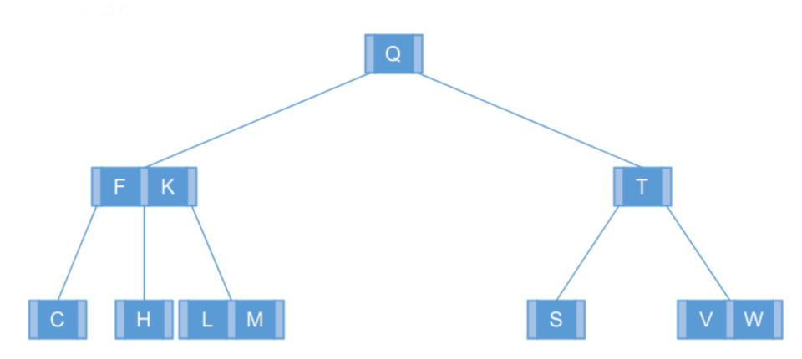（10points）

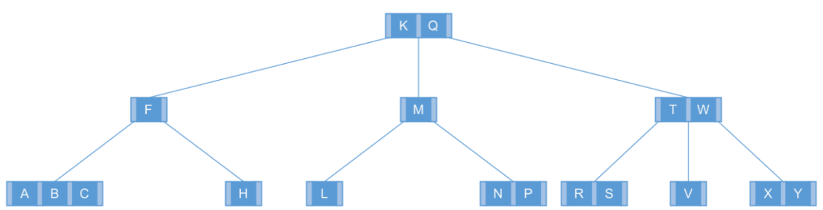（20points）

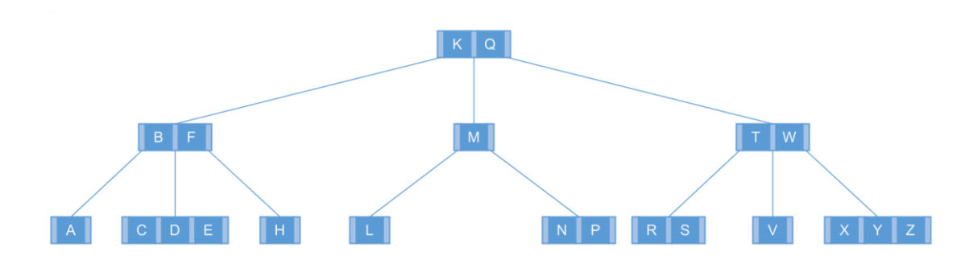

（30points）

[在从上往下插入A的时候FKM已经分裂]

3.The table below lists all possible 2-3-4 tree shapes that could resultfrom inserting N distinct keys into an initially empty tree using top-down insertion, for N between 1 and 6. The left column is the number of keys, the next column is the number of possible trees with that many keys, all of which are drawn on the right (with dots indicating the key values). Complete the two bottom rows of the table (draw the three trees with 5 keys（10points）and enter the count （10points）and draw the trees with 6 keys（20points）)（40points）

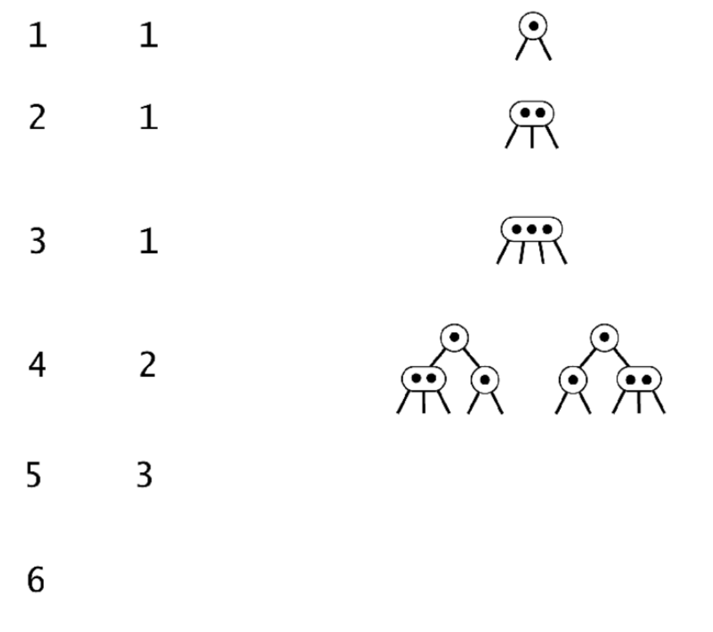

ANS：

